Multi-Scale Sequential Shift Detector
for Deployed RL Agents in Safety-Critical Environments
Research Proposal — ELEC70122 ML for Safety-Critical Decision-Making
4-Week Group Project | 3 Members | Feb 2026

1. Motivation and Problem
A trained RL agent carries an implicit assumption: the world at deployment looks like the world during training. In safety-critical settings this assumption is routinely violated. Sensors degrade. Physics parameters drift. Rare dangerous states appear that were never seen in training. When this happens, the agent's performance silently erodes — with no internal signal to the system or its operators.

Existing deployment monitors address this with a single global statistic (MMD, KS test, C2ST). These produce a binary alarm: shift detected or not. They tell the operator nothing about what kind of shift occurred, which is the information actually needed to decide how to respond.

The core gap: no current deployment monitor for RL agents provides a diagnostic decomposition of shift type. An operator seeing a binary alarm cannot tell whether the observation mean has drifted (suggesting gradual environmental change), whether dangerous tail states have appeared (suggesting a new hazard), or whether feature correlations have changed (suggesting sensor failure). These require different responses. MSSD provides the decomposition.

2. The Central Claim
MSSD is a runtime monitor that wraps any deployed RL agent without modifying it. It watches the stream of observations and, when a shift is detected, reports which aspect of the distribution changed. The central claim is narrow and testable:

Claim | What it means | How we test it
Probe selectivity | Each of the three probes fires significantly more often on its matched shift type than on others | Orthogonality heatmap: fraction of trials where each probe fires first, across three injected shift types. Diagonal should dominate.
Diagnostic value | Knowing which probe fired gives the operator more information than a binary alarm | Compare probe-identity accuracy (does the fired probe match the actual shift type?) against a single-probe global MMD baseline
Sequential validity | The anytime-valid guarantee holds: false alarm rate on unperturbed episodes stays below alpha = 0.05 | False alarm rate measured across 50 in-distribution episodes per environment

We do not claim MSSD is a real-time emergency stop. Window-based two-sample tests require accumulating observations to achieve statistical power, making them appropriate for sustained drift and recurring tail contamination — not single-timestep hazards. This is an honest design boundary, not a limitation to hide.

3. Framework Design

3.1 What MSSD Monitors
The input is the raw observation stream s_t received by the agent at inference time. We monitor observations only — not rewards, actions, or internal policy states. This makes MSSD architecture-agnostic and applicable to any RL agent without modification.

A reference window W_ref is built from N_ref = 2000 observations collected during 20 evaluation rollouts of the trained, frozen agent on the unperturbed environment (final 10% of training). During deployment, a sliding test window W_test of the N_test most recent observations is compared to W_ref continuously.

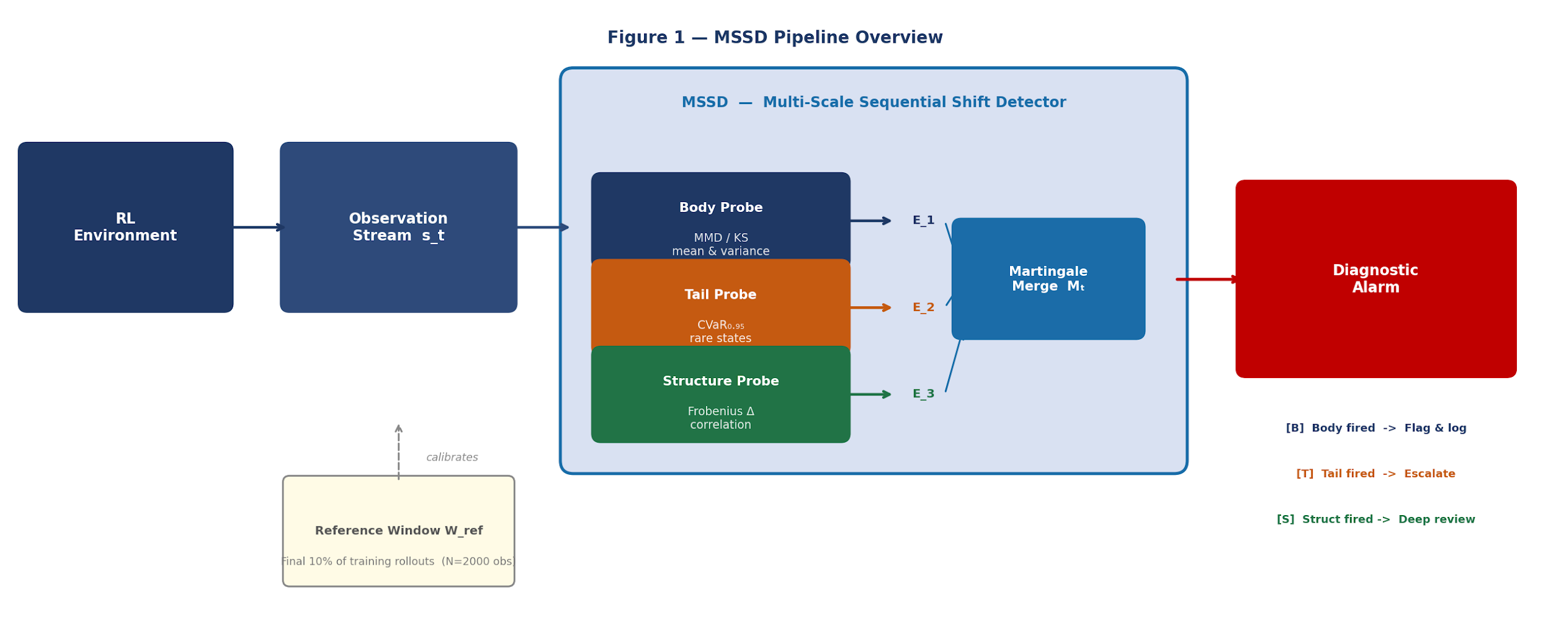
Figure 1 — MSSD pipeline. The three probes each produce an e-value; these are merged into a martingale Mₜ. An alarm fires when Mₜ > 1/α, with the probe identity providing the diagnostic.

3.2 The Three Probes
Each probe targets a distinct, orthogonal aspect of the observation distribution:

Probe | Statistical test | What shift it detects | Novelty
Body | MMD (RBF kernel, d > 4) or KS (d <= 4) | Mean and variance shift — the bulk of the distribution moves | Established baseline; provides comparison anchor
Tail (CVaR) | Difference in CVaR_0.95 of a learned 1D projection between W_ref and W_test | Rare dangerous state injection — tail statistics change while mean is approximately unchanged | First application of CVaR as a calibrated two-sample probe for RL observation monitoring
Structure | Frobenius distance between empirical correlation matrices of W_ref and W_test | Inter-feature correlation breakdown — e.g. sensor decoupling, hidden state change | Detects a class of shift invisible to both MMD and tail probes

3.3 Anytime-Valid Sequential Testing
Each probe produces a raw statistic calibrated into an e-value via block-bootstrap permutation. Blocks of length l_block approximate the environment mixing time, preserving Markov temporal structure that standard permutation destroys. The three e-values are merged (Vovk & Wang 2021 weighted mean) and accumulated as a product martingale. An alarm fires when log(Mₜ) > log(1/alpha). This provides an anytime-valid false alarm guarantee at level alpha regardless of when the test is evaluated.

4. Experimental Environments
We use two standard Gymnasium environments that stress-test different shift regimes. The environments are simple enough that shift injection is clean and reproducible, and complex enough to be credible proxies for real deployment settings.

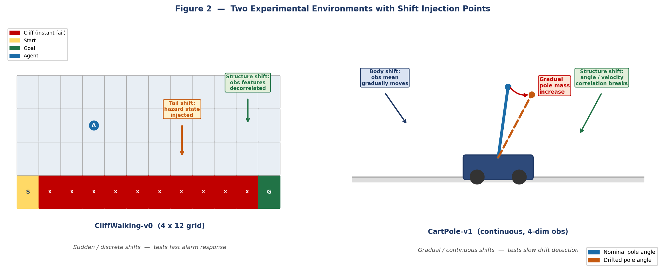
Figure 2 — Left: CliffWalking-v0 with sudden shift injection points. Right: CartPole-v1 with gradual physics drift. Same three probes, two operating regimes.

Environment | Observation space | Trained agent | Shift regime | Shift types injected
CliffWalking-v0 | 3-dim: (row, col, cliff_distance) | Tabular Q-learning, ~500 episodes | Sudden / discrete | Body: coordinate offset. Tail: hazard state injection (p=0.03). Structure: feature decorrelation.
CartPole-v1 | 4-dim: (x, x_dot, theta, theta_dot) | DQN, ~300 episodes | Gradual / continuous | Body: pole mass increases linearly. Tail: rare extreme-angle states injected. Structure: x and theta correlation broken.

Each shift is injected at a known timestep T_shift. Shift magnitude is parameterised and swept across three levels (mild, moderate, severe). All experiments run 50 independent trials per condition.

5. Evaluation

5.1 Primary Metrics
Metric | Definition | Research question
Probe discrimination accuracy | Fraction of trials where the first-firing probe matches the injected shift type | RQ1: Does MSSD correctly identify what changed?
Average Detection Delay (ADD) | E[T_alarm - T_shift] across trials, per shift type and severity | RQ2: How quickly does the correct probe detect its matched shift?
False alarm rate (FAR) | Fraction of unperturbed episodes where Mₜ exceeds threshold before episode end | RQ3: Is the anytime-valid guarantee respected?
ADD vs. global MMD baseline | Head-to-head ADD comparison: matched probe vs. single global MMD detector | RQ4: Does decomposition provide detection speed benefit on tail and structure shifts?

5.2 The Orthogonality Heatmap
The key visualisation is a 3x3 heatmap: rows are injected shift types (body, tail, structure), columns are probes, cells are the fraction of trials where that probe fires first. A successful result has a dominant diagonal. This is the single figure that most directly demonstrates the core claim.

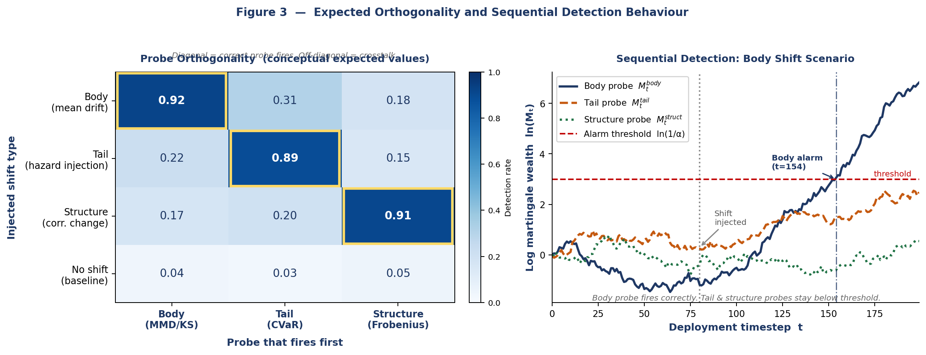
Figure 3 — Left: conceptual expected orthogonality heatmap (diagonal-dominant = probe selectivity confirmed). Right: example martingale log-wealth trajectories for a body-shift scenario — body probe fires, tail and structure stay below threshold.

5.3 Honest Null Result Framings
The following interpretations are prepared in advance for each possible negative outcome:

- If probes are not selective (flat heatmap): reports that the three shift types are not geometrically separable in this observation space using these statistics, and identifies which shift types are confounded. This is itself an informative finding about the limits of two-sample decomposition.
- If CVaR tail probe does not outperform MMD on tail shifts: reports that in these environments, tail contamination co-occurs with sufficient mean shift that MMD captures it equally well. Motivates future work on higher-dimensional embeddings where tail and body signals separate.
- If FAR exceeds alpha: diagnoses the block length calibration — block bootstrap validity depends on the mixing time estimate, and failure here is informative about temporal autocorrelation structure in these environments.

Cherry-picking threshold values or probe weights post-hoc to improve reported metrics is not permitted. All hyperparameters are fixed before experiments begin.

6. Four-Week Execution Plan
Week | Owner | Concrete output by end of week
1 | Person A (CS) | Environments set up. Q-agent and DQN trained and frozen. Shift injection functions written and verified. Reference window W_ref collected for both envs. Output: train.py, shift_injector.py, reference_window.npy.
1 | Person B (CS) | Three probe classes implemented with unit tests on toy Gaussian data where the answer is known. Block-bootstrap calibration implemented and validated on synthetic IID streams. Output: probes.py, test_probes.py.
1 | Person C (non-CS) | Related work section drafted (Rabanser 2019, Podkopaev 2022, Amoukou NeurIPS 2024, Vovk & Wang 2021). Motivation and gap analysis written. Output: sections 1-2 of report draft.
2 | A + B | Full MSSD class wiring all three probes into martingale. Probe orthogonality validated on synthetic Gaussian streams (controlled, known shifts). All three probes confirmed selective on synthetic data before touching RL environments. Output: mssd.py, orthogonality_synth.png.
2 | C | Methodology section written. Evaluation metrics table drafted. Output: section 3 of report.
3 | A + B | Full RL experiments: 50 trials x 3 shift types x 3 severities x 2 environments. All four primary metrics computed. Output: results_table.csv, orthogonality_heatmap.png, add_comparison.png, martingale_curves.png.
3 | C | Results and discussion sections written as figures arrive. Output: sections 4-5 of report.
4 | All | Integration, consistency pass, abstract and conclusion written, figures polished to publication quality. Final report PDF. Output: MSSD_final_report.pdf.

7. Novelty and Positioning
Contribution | Closest prior work | Gap we fill
CVaR as two-sample probe for RL observation tail shifts | CVaR in risk-sensitive RL reward shaping (Tamar et al. 2015); tail tests in supervised ML (He et al. 2010) | No prior work applies CVaR as a calibrated two-sample statistic for monitoring the observation space of a deployed RL agent
Diagnostic decomposition of shift type for RL deployment | Rabanser et al. 2019 (supervised ML, no RL); Podkopaev & Ramdas 2022 (binary alarm only) | All existing RL deployment monitors produce binary alarms; none report which aspect of the distribution changed
Block-bootstrap e-value calibration for Markov observation streams | E-values (Vovk & Wang 2021); block bootstrap for Markov chains (Bertail & Clemencon 2006) | Existing sequential shift detectors assume i.i.d. observations; this is violated in RL deployment

8. Key References
Rabanser, Gunnemann & Lipton. Failing Loudly: An Empirical Study of Methods for Detecting Dataset Shift. NeurIPS, 2019.
Podkopaev & Ramdas. Tracking the risk of a deployed model and detecting harmful distribution shifts. arXiv:2110.06177, 2022.
Amoukou et al. Sequential Harmful Shift Detection Without Labels. NeurIPS, 2024.
Vovk & Wang. E-values: Calibration, combination and applications. Annals of Statistics, 2021.
He, Hsu & Hu. Detection of Treatment Effects by Covariate-Adjusted Expected Shortfall. Annals of Applied Statistics, 2010.
Bertail & Clemencon. Regenerative block-bootstrap for Markov chains. Bernoulli, 2006.
Tamar, Glassner & Mannor. Optimizing the CVaR via Stochastic Gradient Descent. AAAI, 2015.
Gretton et al. A Kernel Two-Sample Test. JMLR 13, 2012.
Hindy, Luo, Banerjee, Kuck, Schmerling & Pavone (2024) — "Diagnostic Runtime Monitoring with Martingales" (arXiv:2407.21748, Stanford ASL / NVIDIA)

ELEC70122 Group Project Proposal | February 2026

